**VirtualBox installation**

1. First we need to download recent version of VirtualBox from <https://www.virtualbox.org>.
2. Run the executable and follow the prompts to complete the installation. We don’t really need to change anything for our purposes, and can accept the defaults. Before completing the wizard you will get a warning that the network connection will temporarily be interrupted, so make sure you’re doing anything that would be impacted, like being half-way through downloading a 16GB file that can’t be resumed.

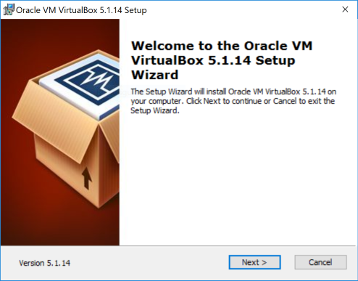

**Create an Ubuntu virtual machine**

1. Download the latest Ubuntu release iso file from <https://www.ubuntu.com/download/desktop>.
2. Open VirtualBox and click **New**

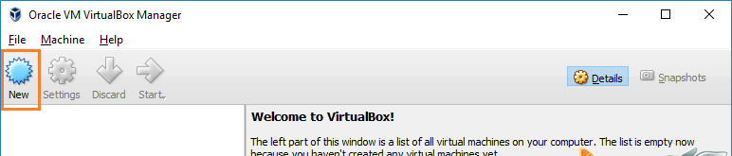

1. Type the *Name* for the virtual machine, like Ubuntu 16. VirtualBox will try to predict the *Type* and *Version* based on the name you enter. Otherwise, select:
   * Type: Linux
   * Version: Ubuntu (64-bit)

and click **Next**.

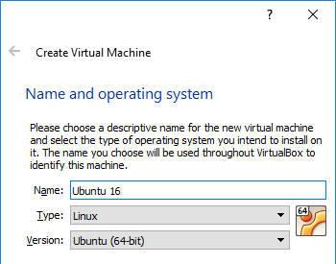

1. Next we need to specify how much memory to allocate the virtual machine. According to the Ubuntu [system requirements](https://www.ubuntu.com/download/desktop) we need 2GB, but I’d recommend more if your host can handle it. Basically the higher you can set the memory without severly impacting your host machine, the better the performance of the guest machine. If you’re not sure, stick with 2GB.

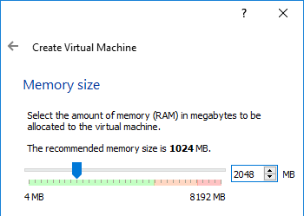

1. On the **Hardware** screen select **Create a virtual hard disk now** and click **Create**
2. Accept the default option **VDI** for **Hard disk file type** (or change it if you wish…) and click **Next**
3. Next we are prompted for **Storage on physical hard disk**. The options are *Dynamically allocated* and *Fixed size*. We’ll use the default of **Dynamically allocated**. Click **Next**

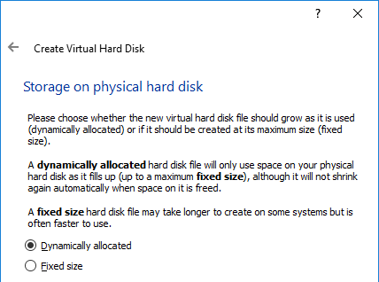

1. Choose the hard disk size and storage location. The Ubuntu system requirements recommend 25GB. Remember, we choose *Dynamically allocated* as our storage option in the last step, so we won’t consume all this disk space immediately. Rather, VirtualBox will allocate it as required, up to the maximum 25GB we specified. Click **Create**
2. The wizard will finish and we are returned to the main VirtualBox window. Click **Settings**

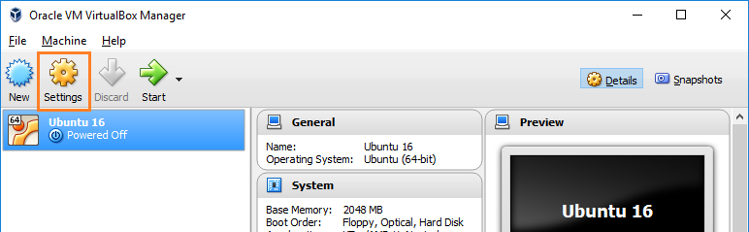

1. In the left pane select **Storage**, then in the right select the CD icon with the word Empty beside it.

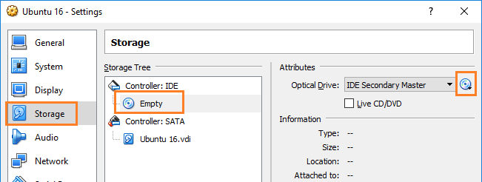

1. Under *Attributes* click the CD icon (highlighted in the screenshot above) and select **Choose Virtual Optical Disk File** and browse to the downloaded file ubuntu-16.04.1-desktop-amd64.iso

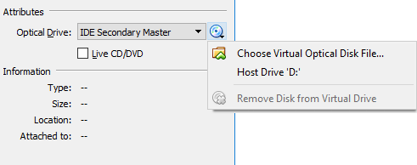

1. Click **OK** to close the *Settings* dialog window. The virtual machine should now be ready to start.

**Install Ubuntu**

In VirtualBox your VM should be showing as *Powered Off*, and the optical drive configured to point to the Ubuntu ISO file we downloaded previously.

1. In VirtualBox, select the virtual machine **Ubuntu 16** and click **Start**. VirtualBox will launch a new window with the vm and boot from the iso.

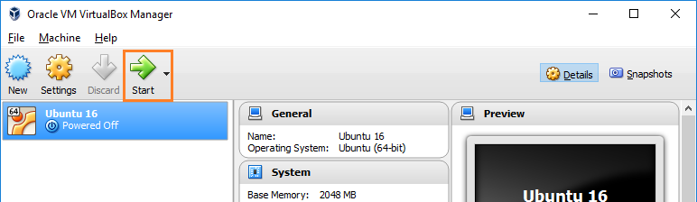

1. Click **Install Ubuntu**

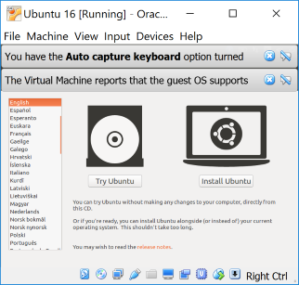

1. Select **Download updates while installing Ubuntu** and click **Continue**
2. On the next screen accept the default of **Erase disk and install Ubuntu** and click **Install Now**

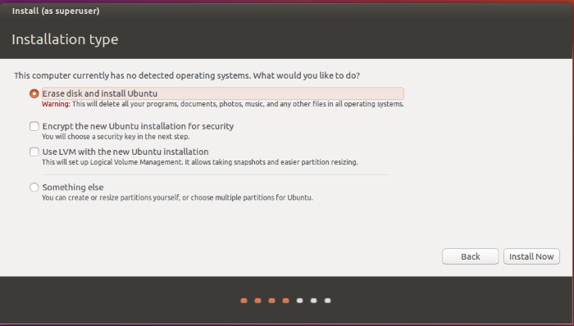

1. You will be prompted with a warning saying the changes will be written to disk. Click **Continue**

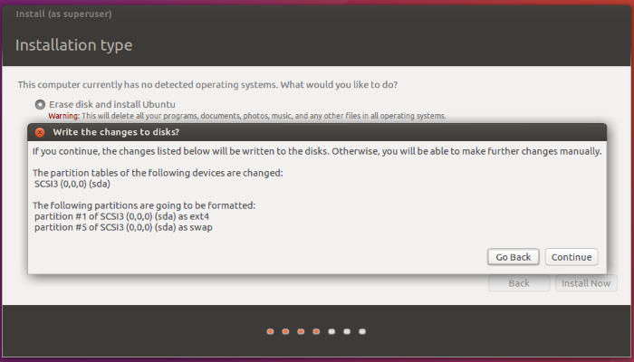

1. Select your timezone and click **Continue**
2. Select your keyboard layout. I accepted the default of **English (US)** and click **Continue**
3. Enter a username and password, then click **Continue**

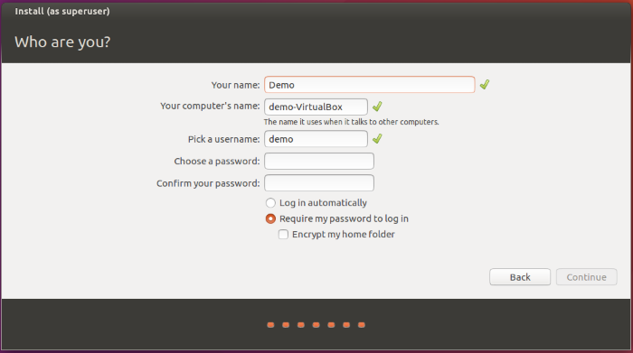

1. The Ubuntu installation may take several minutes to run, so have another coffee.

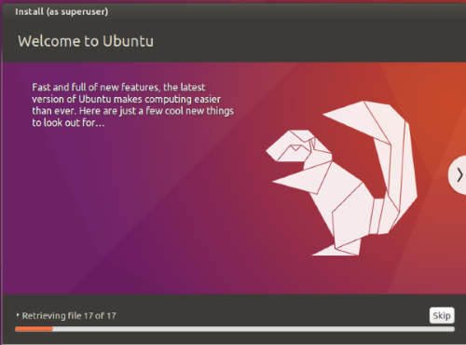

1. When the installation is finished you will be prompted to restart. Save and close anything else you may have open and click **Restart Now**

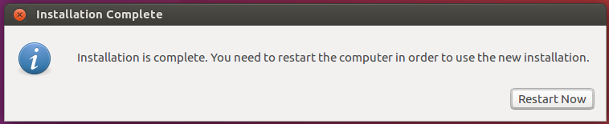

1. Now when the vm reboots you may see this message.

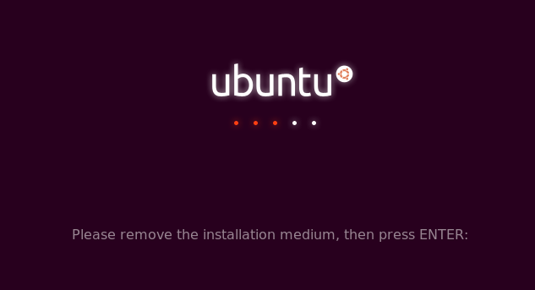

From the menu select **Machine > Settings**.

Navigate back into the **Storage** settings where we previously selected the iso file. If the Ubuntu iso file is still there, remove it. Otherwise close the *Settings* window and in the vm press **Enter** to proceed.

1. If all went well the VM should boot to the Ubuntu login screen. Enter your password to continue.

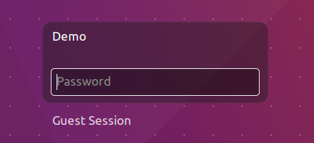

Ubuntu should run normally in the VirtualBox environment. If everything is far too small, you can adjust the ‘zoom’, so to spea, by selecting ***View > Scale Factor > 200%***.

Have fun!